Day 5

1.GET method

2.POST method

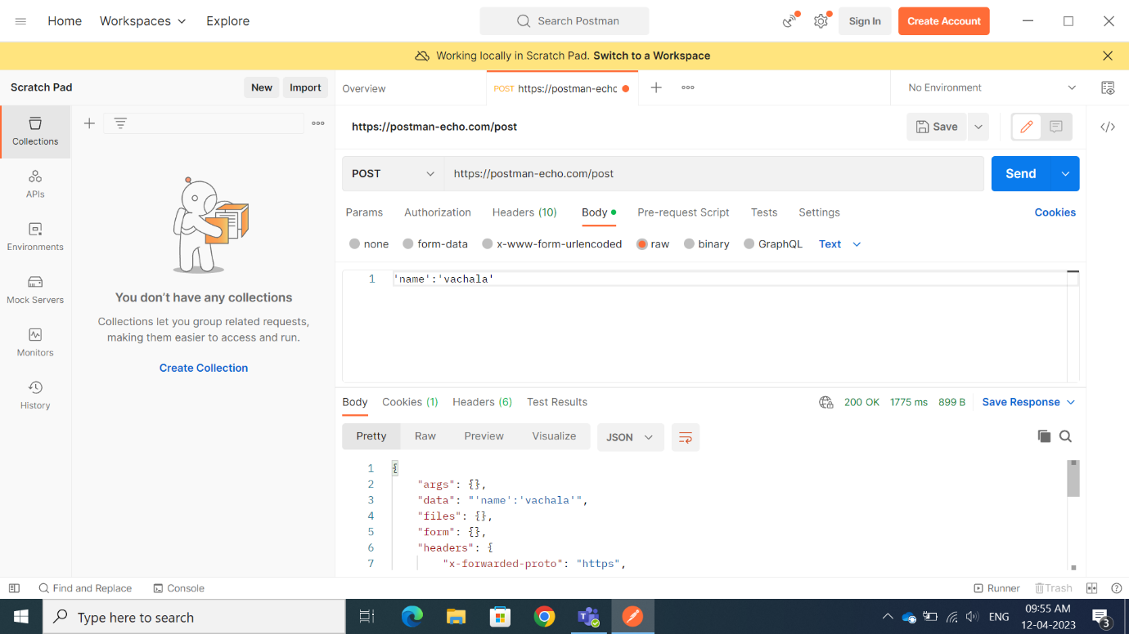

3.PUT method

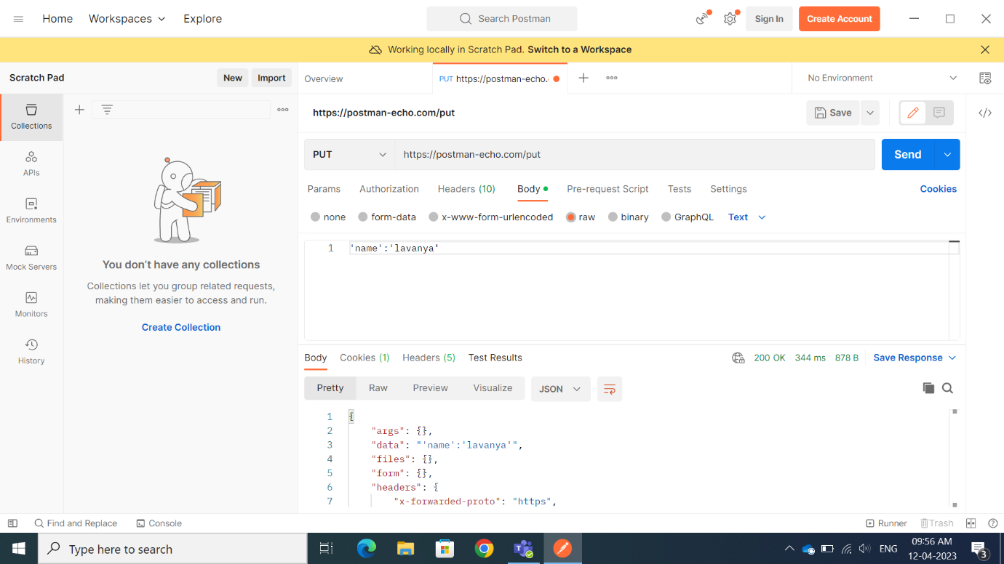

4.DELETE method

